# **Clinic Website & Interface**

# **Reference Doc**

## **Group Members:**

Austin Hegarty

David Howard

John Luce

Josh Remillard

Kathleen Niekrewicz

Ryan Shirlock

## **Notes:**

* Perhaps we should include more information similar to a requirements doc (Below found in Ch. 4)? Some info like:

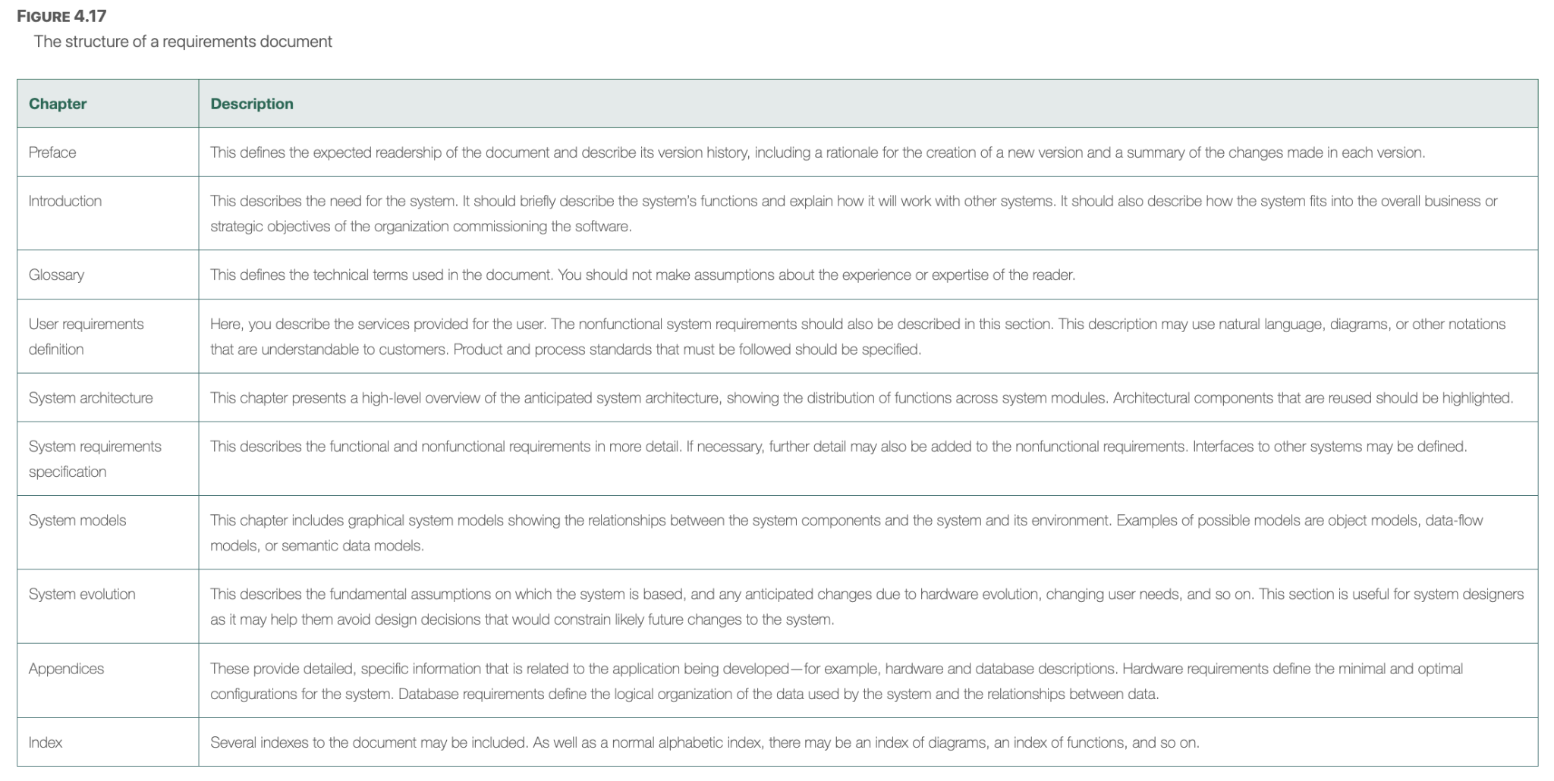

## **Aspects/Tasks:**

Webpage

Appointments

Practitioner interface

Health records

Database Interface

## **General Webpage Layout:**

* Simplifying/better organizing UI elements we saw.
* Replace client info from heading with logo/branding (if available).
* Add a homepage as a starting point (if there isn’t one already)?
* Adjust client selection menu/list.
* System to allow practitioners to take notes.

## **Appointments:**

* Polish Appointment Function.
* Adding Calendar (30 minute blocks).
* Maybe implement the calendar in other areas of the project.
* Adding daily/weekly/monthly views for practitioner/patient.
* Attendance Functionality.
* Notifications as a maybe addition.
* Duration of appointment.

## **Practitioner/Student/Receptionist Interface:**

* What should the student see vs. a practitioner?
* Different levels of access between receptionists, students, and practitioners.
* Practitioners need to see Active/Inactive problems, surgeries/past medical history
* Practitioners can’t access financial and insurance information.
* Student can look info up on patients, and do Progress notes, but cant do prescription and lab orders.
* Receptionist can’t see Medical info, but need Insurance, contact info, general info.

(Would we need a separate receptionist interface? Wouldn't a receptionist be able to adjust a given practitioner's schedule or basic patient info, like meds?)

(Maybe practitioners and receptionists have the same interface but have different access to certain documents and records?)

(Admins have full access, add/remove user accounts)

(Practitioners have full access to only patients under their care)

(Receptionists add/remove patient accounts, have basic access to patient info and financial records)

(Could some info be done automatically? Like age?)

(Maybe a question for Clinic/Database?)

(Sounds like we will need a student/assistant/apprentice interface, prioritize that over receptionist )

## **Health Records & Database:**

* Separate available records based on practitioner (Should all staff members be able to manage a single patient?)
* Define data to be stored (Need the database outline from the database group/group 2).
* Include Preferred/prevoiusly visited doctors for patient? (Patients may/may not prefer to have the same doctor they had last time they visited)
* For birthdate (this is automation to determine the age):
  + Subtract current year from birth year (gets a general age)
  + Compare birth month from current month
    - If birthMonth > current month, then generalAge -1 = age
    - ElseIf BirthMonth = Current Month,
      * If birthday > currentday, then generalAge -1 = age
    - else leave the age the same
  + If previous statement returns false, compare birthdate with current date

## **Miscellaneous:**

### Things to do:

* Test current project build.
* Refresh PHP, CSS, & HTML knowledge.
* Get feedback from client regarding previous build/webpage.
* Get feedback from last year’s class, regarding webpage (example: Nick).
* Write up new requirements.
* Make up spreadsheet for task organization (Task name, work type, # of people needed, time required, etc.)
* Develop a timeline.
* Make a sitemap.
* Build a HTML Webpage (Index.html) to launch the website from.

### Questions to Ask:

* Do we use PHP or a different language? (I think we should work with HTML, for testing at the least)
* Starting over or keeping the old version? (Probably work from “latest” build?)
* Building a calendar from scratch or use an API?
* Does the clinic have a logo & color palette, or just a name?
* How to implement User accounts (Admin, Pediatritian/Doctor, Patient, Receptionist, Student)

### Client Questions:

* Ask what specific things a student can and can’t access that a practitioner can?
  + Can't do prescription and lab orders,
  + Can look info up on patients
  + Progress notes
* Ask the client about the calendar idea.

- Yes.

* Recept:
  + No Medical info, Insurance, contact info, general info

## **General Website Outline:**

* Users log into the website, & reach the homepage.
* Users can select a patient under their care from a list, containing basic details. (Name, birthdate, age, sex/gender, etc.)
* Once a patient is selected (by a practitioner), patient entry becomes more detailed (Height, weight, etc.). Users can then view/edit their records.
* Receptionists can view/modify practitioner appointments and patient appointments, and handle finances. They can’t see patient health information.